Assignment 5 Task 2
Step 1
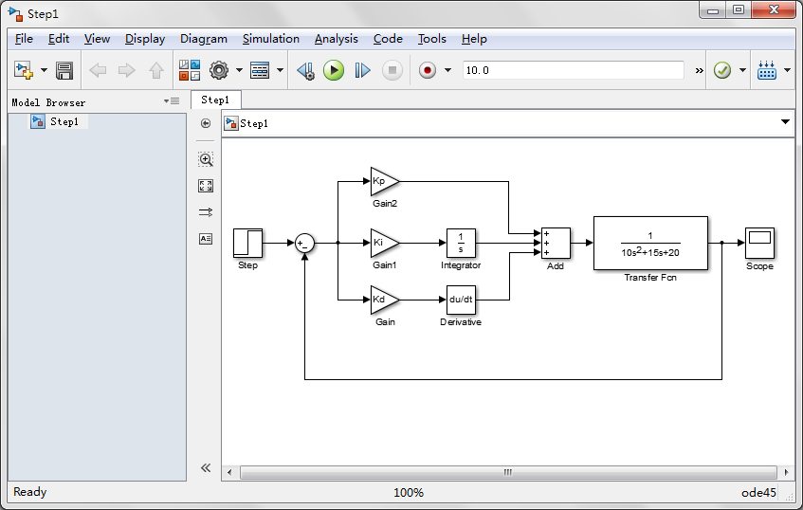
Step 2
(1) Kp = 2 ;Ki = 0.5 ; Kd = 0; (2)Kp = 8 ;Ki = 0.5 ; Kd = 0;
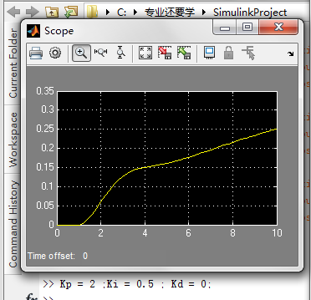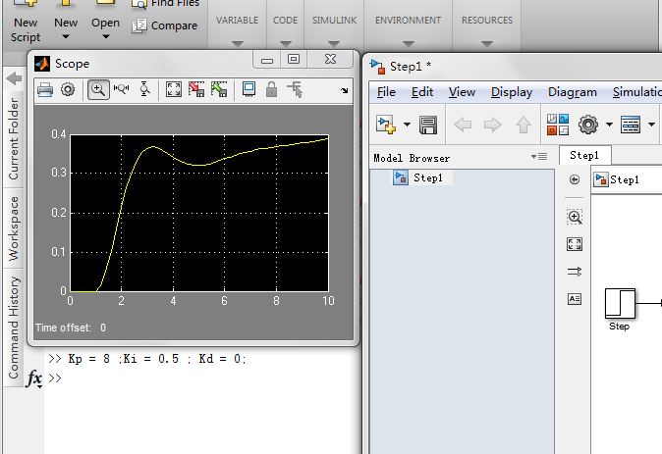

(3)Kp = 8 ;Ki = 1 ; Kd = 0; (4)Kp = 16 ;Ki = 1 ; Kd = 0;
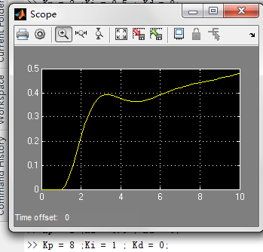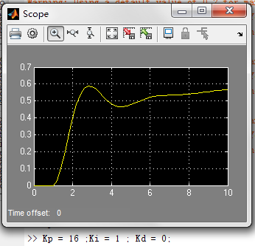
(5)Kp = 32 ;Ki = 1 ; Kd = 0; (6)Kp = 64 ;Ki = 1 ; Kd = 0;
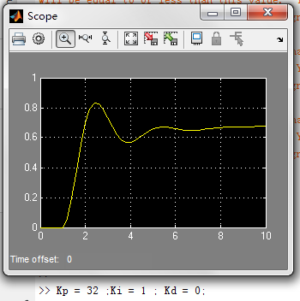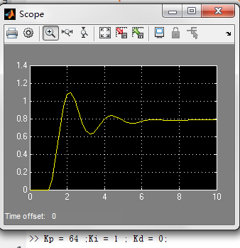

(7)Kp = 512 ;Ki = 32 ; Kd = 32;
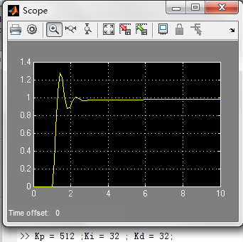
Step 3
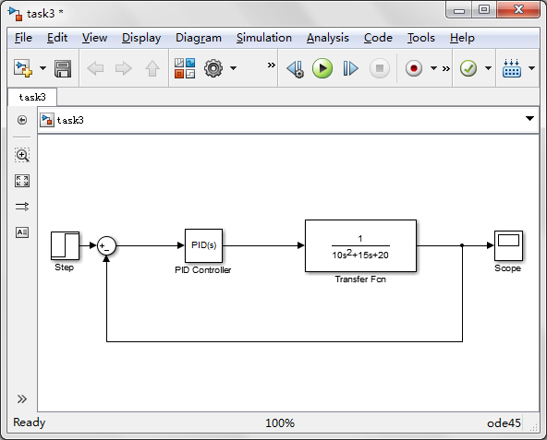

Step 4
(1)P = 1 I =1 D = 0
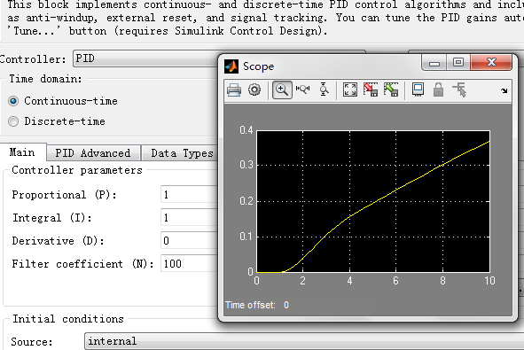

- P = 32, I = 1, D= 0
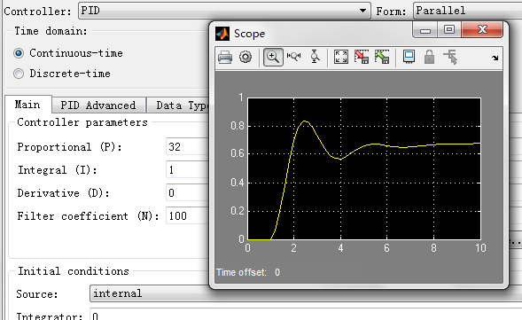
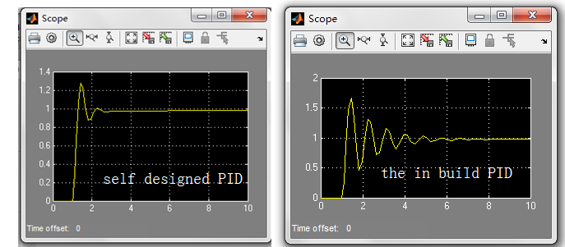
If only the P, I parameters are used, the control I designed is the same as ”the in-build Simulink functionality“.
But because I add the D parameter ,so “the in-build Simulink functionality PID”is slower than it.
Step 5
- : “P” means the proportional part of the signal. And it determines the output directly.
It stands for the current value of the e(t). If we tune P lager, it will response faster. If we tune P smaller, it will response slower.
- : “I” means the integral part of the e(t). As it accumulates the value of the error--e(t).
And it will help to make the response to be stable. When we tune I lager, we can reduce the oscillation.
- : “D”means the derivative part of the e(t). So it stands for the current rate of the change of the error. With tuning“I”, we can change the status of the system later.
To conclude, in the PID control, “P” controls the current status, “I”controls the past status, and the “D”controls the future features.

